**Appendix III: Intervention 1 – Test**

**Exercise 1:** On which side was the bed? (left/right)

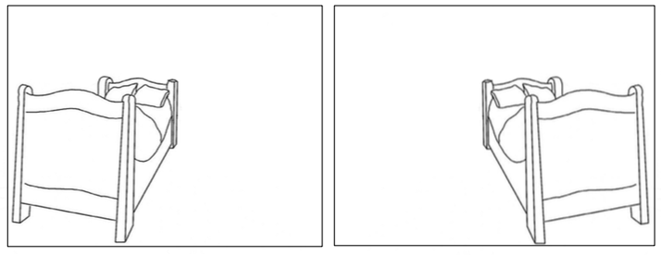

**Exercise 2:** At which height was the window? (up/down)

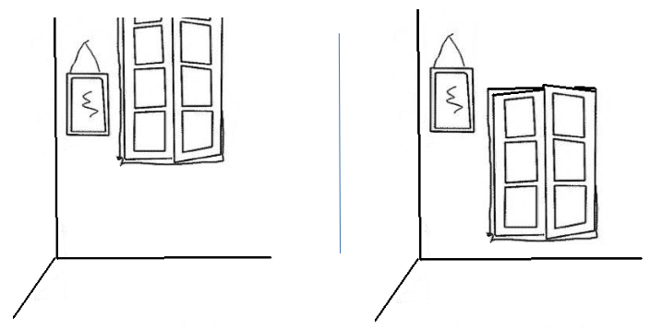

**Exercise 3:** Which of these objects was not in the painting?

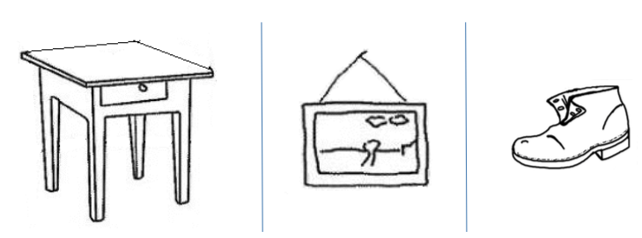

**Exercise 4:** How many chairs were there in the painting?

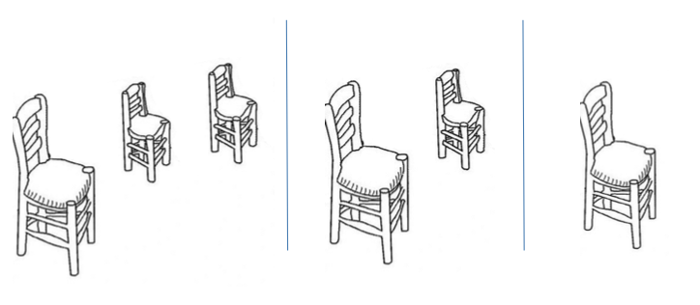

**Exercise 5:** What color was the door?

